IOT Prison Break Monitoring & Alerting System

Well it is a quite shocking fact but prison escapes are not very uncommon occurrences. There is no exact data count but we have all heard and still keep hearing of a variety of prison escapes happening globally. The fact that such number of inmates may still be roaming among us is itself scary. Well so here we propose a prisoner tracking system that helps detect prison breaks and instantly alert authorities using IOT. The system makes use of a microcontroller based circuit to achieve the task using rf technology. We make use of RF trackers on each inmate to detect their presence in the premises. The 2 central monitoring units are used to scan through all inmates as per data fed to it and constantly keep track of each prisoner.
Each prisoner is mounted with a rf tracker transmitting a unique prisoner code wirelessly. Whenever a prisoner exits the facility the centralized system is unable to receive his/her code. At that time the receiver circuitry instructs the controller to tack action against particular prisoner. The System now transmits the prisoner details over to the officers alerting portal to send out instant alert and catch the prisoner before he runs even 50 meters away from the facility. Here we use IOTGecko to develop the online alerting portal system to receive input from monitoring device and display alert and sound alarm through internet.

Block Diagram:
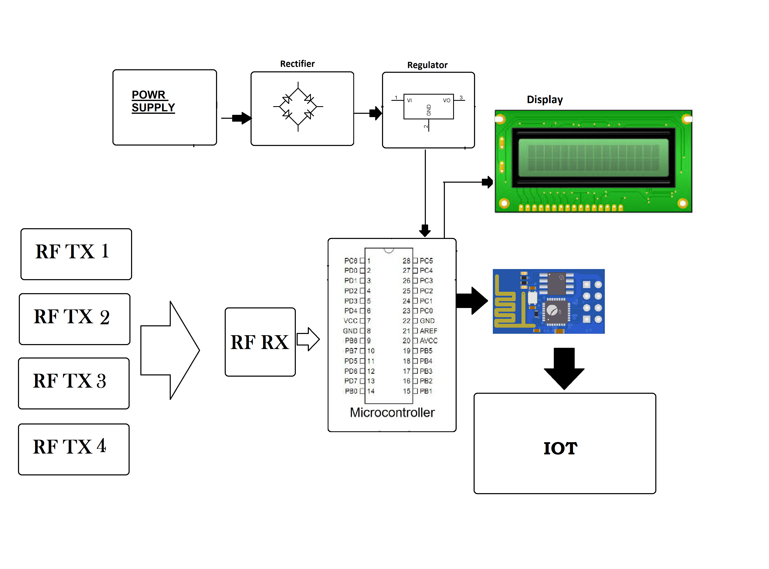

Hardware Specifications

- Atmega Microcontroller

- Wifi Module
- RF Tx Rx

- Buzzer

- Crystal Oscillator
- Resistors

- Capacitors

- Transistors
- Cables and Connectors

- Diodes

- PCB and Breadboards
- LED

- Transformer/Adapter

- Push Buttons
- Switch

- IC

- IC Sockets
- Software Specifications

- Arduino Compiler

- MC Programming Language: C
- IOT Gecko

Software Specifications
- Arduino compiler
- Programming Language: C
- IOTGecko

